**What is Azure Storage?**

* Azure Storage is the Azure platform's managed service for providing cloud storage. Azure Storage is composed of several core services and supporting features. It is highly available, secure, durable, scalable, and redundant.
* The word ‘Blob’ expands to a Binary Large Object. Blobs include images, text files, videos and audios. Azure Blob storage is Microsoft's object storage solution for the cloud and it is optimized for storing massive amounts of unstructured data. Unstructured data is data that doesn't adhere to a particular data model or definition, such as text or binary data.
* With Azure Blob Storage, the files (photos, videos, training documents, etc.), which are known as blobs, are put in containers which function similar to directories. These are then linked to the storage account.
* Azure Files offers fully managed file shares in the cloud that are accessible via the industry standard Server Message Block (SMB) protocol or Network File System (NFS).
* Azure file storage mainly can be used if we want to have a shared drive between two servers or across users. In that case, we will go for Azure file storage.
* We can create an unlimited number of file shares within a storage account. Once we create a file share, then we can create directories, just like folders, and then we can upload files into it. Once we create a file share, we can mount that on any virtual machine, whether it is in Azure or outside.

**There are different types of replications that you can perform in Azure. They are:-**

**LRS:-**In the main region, locally redundant storage (LRS) duplicates your data three times inside a single data center. This kind of redundancy is useful for Rack Failures within the data center

**ZRS:-** Your Azure Storage data is replicated synchronously across three Azure availability zones in the main region using zone-redundant storage (ZRS). Each availability zone is a physical location with its own power, cooling, and networking infrastructure. This kind of redundancy is useful for data center failures

**GRS:-**Using LRS, geo-redundant storage (GRS) replicates your data three times synchronously inside a single physical location in the primary region. It then asynchronously replicates your data to a single physical place in a secondary area hundreds of kilometers distant from the original region. This kind of is useful for regional failures

**GZRS:-**GZRS (geo-zone-redundant storage) combines the high availability offered by redundancy across availability zones with the protection afforded by geo-replication against regional failures. Data in a GZRS storage account is duplicated to a secondary geographic area for disaster recovery and is replicated across three Azure availability zones in the original region. If an availability zone becomes inaccessible or unrecoverable, you may still read and write data using a GZRS storage account.

The table below describes when to use what kind of replications.

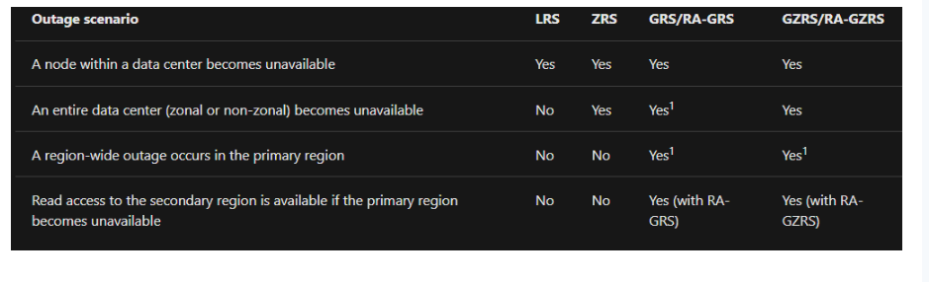

**Access Tiers:-**

Different access levels in Azure storage enable you to store blob object data in the most cost-effective way possible. Tiers of access are available, including:

**Hot** - Designed for storing data that is regularly accessed.

**Cool** - Designed to store data that is viewed rarely and kept for at least 30 days.

There is one more tier called the **archive tier**.

We can change the access tier to archive from Hot/Cold. We can’t mention the storage account blob as an archive directly while creating the storage account